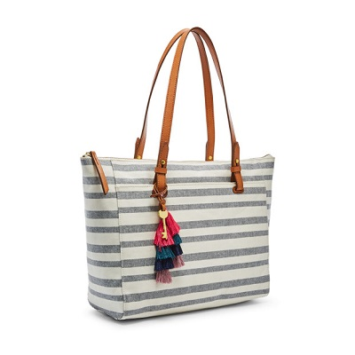

Rachel Tote

PRODUCT DETAILS

**Silhouette: Tote with Zipper**

**Exterior Material: PVC Coated Fabric/Polyurethane Trim**

**Interior Details: 1 Zipper Pocket, 2 Slide Pockets**

**Measurements: 14"L x 4"W x 13"H**

**Handles/Straps: 2 Handles**